**Date: 25.04.2024**

**TEST CASES:**

**CHOICE CASE:**

1. Entering an invalid choice

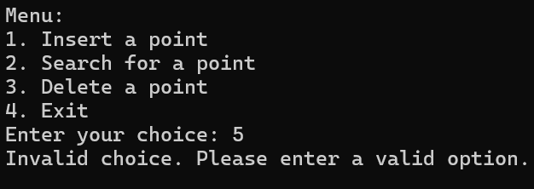

**DIMENSION CASE:**

1. Tree with a dimension less than or equal to 0



**Note**: Values to be inserted must range from -2147483648 to 2147483647 as it is off **int** data type

**INSERTION TEST CASES**:

* 1. Insertion of a point with k-dimensions

2-dimensional tree:

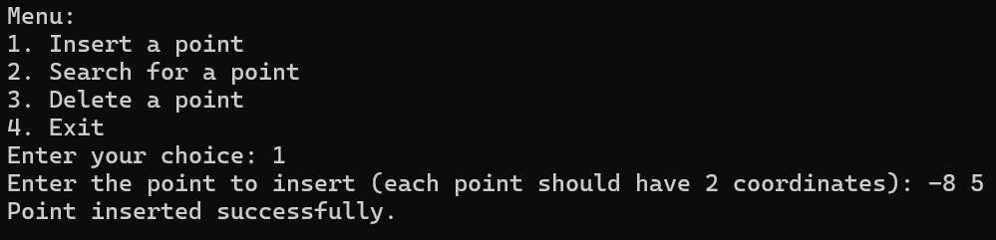

3-dimensional tree:

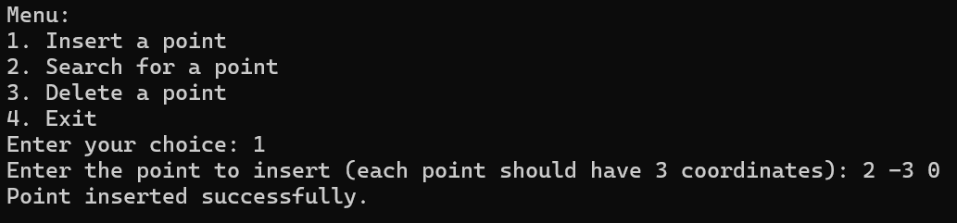

**SEARCH TEST CASES**:

* 1. Search for a point that exists in the tree.

2-dimensional tree:

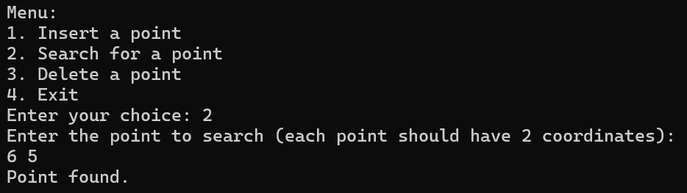

3-dimensional tree:

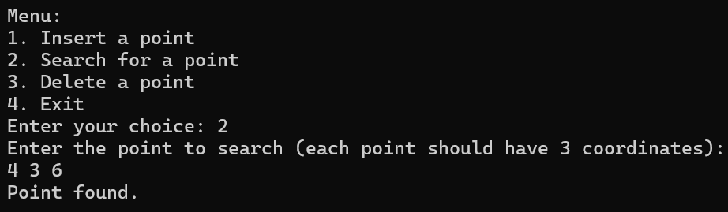

* 1. Search for a point that does not exist in the tree.

2-dimensional tree:

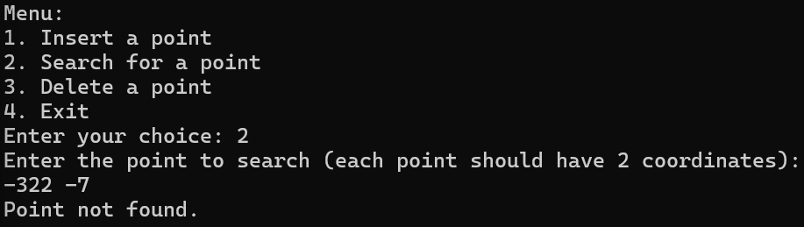

3-dimensional tree:

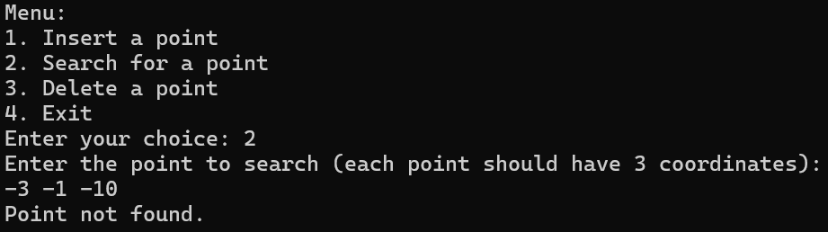

**DELETE CASES**:

1. Delete a point that exists in the tree:

2-dimensional tree:

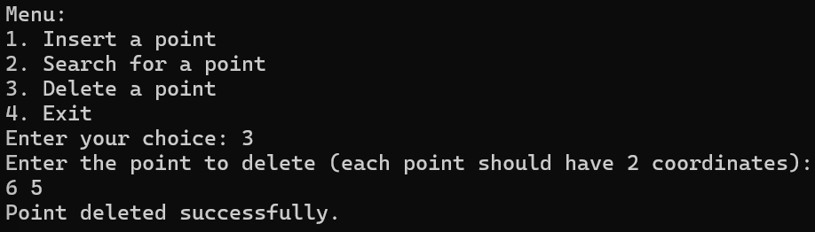

3-dimensional tree:

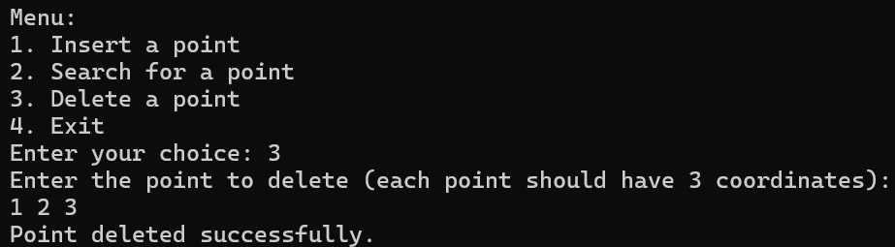

1. Delete a point that does not exist in the tree

2-dimensional tree

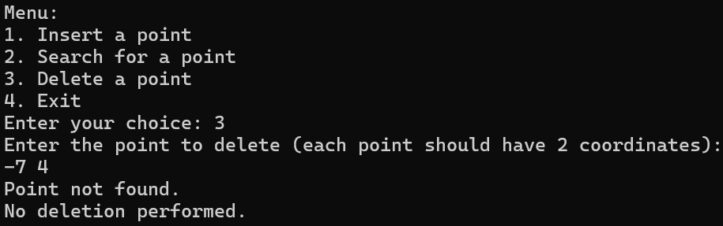

3-dimensional Tree:

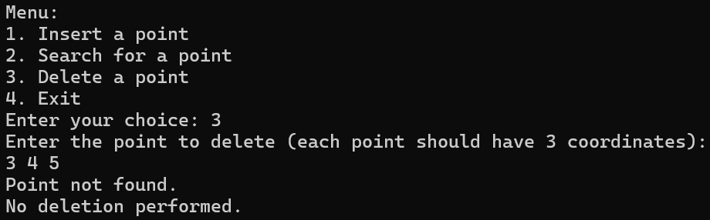

**ERROR HANDLING TEST CASES**:

* 1. Attempt to insert points with invalid input (e.g., non-integer input)

2-dimensional tree:

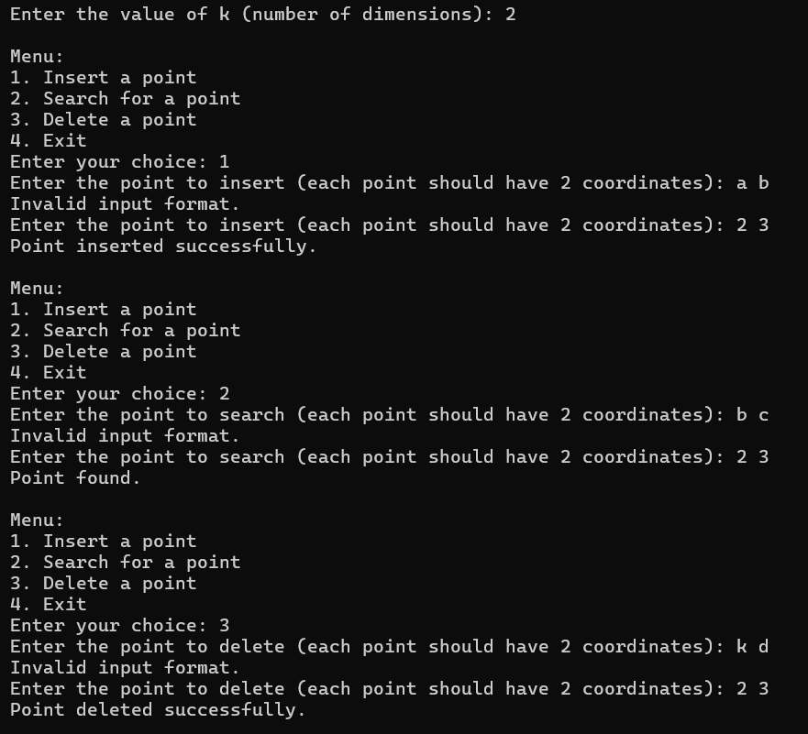

3-dimensional tree:

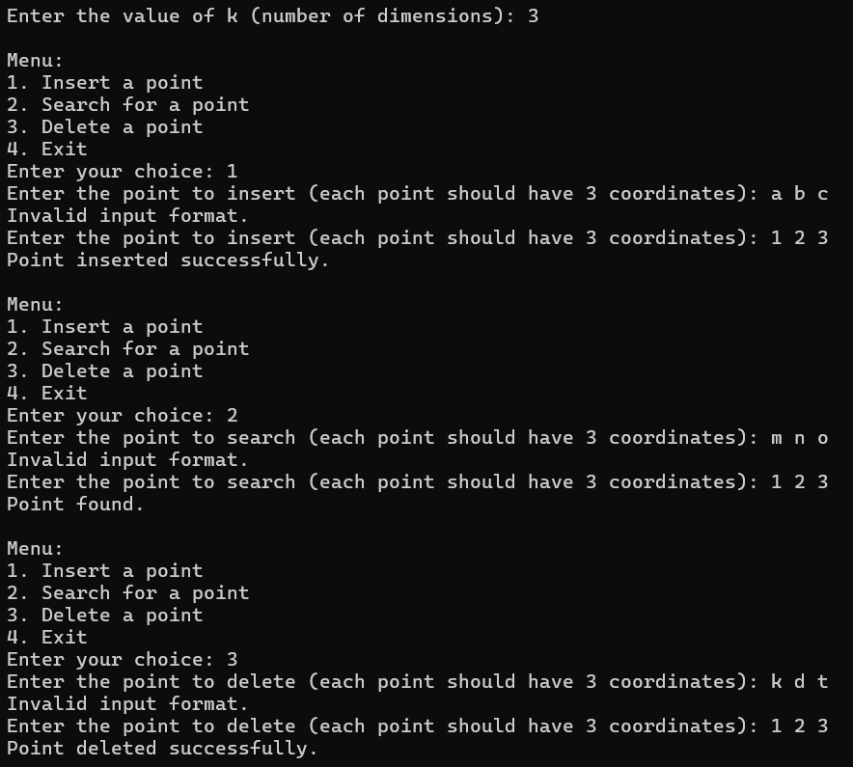

* 1. Attempt to search or delete points from an empty tree.

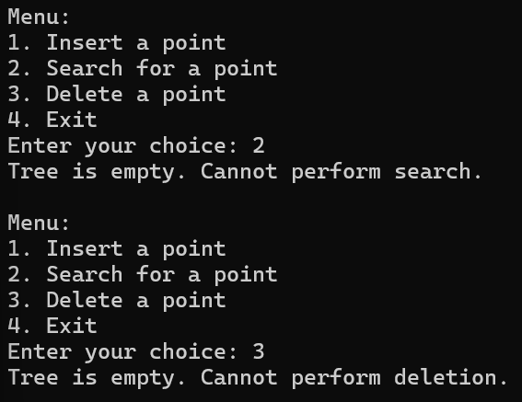

* 1. Attempt to enter non-integer coordinates

2- dimensional tree:

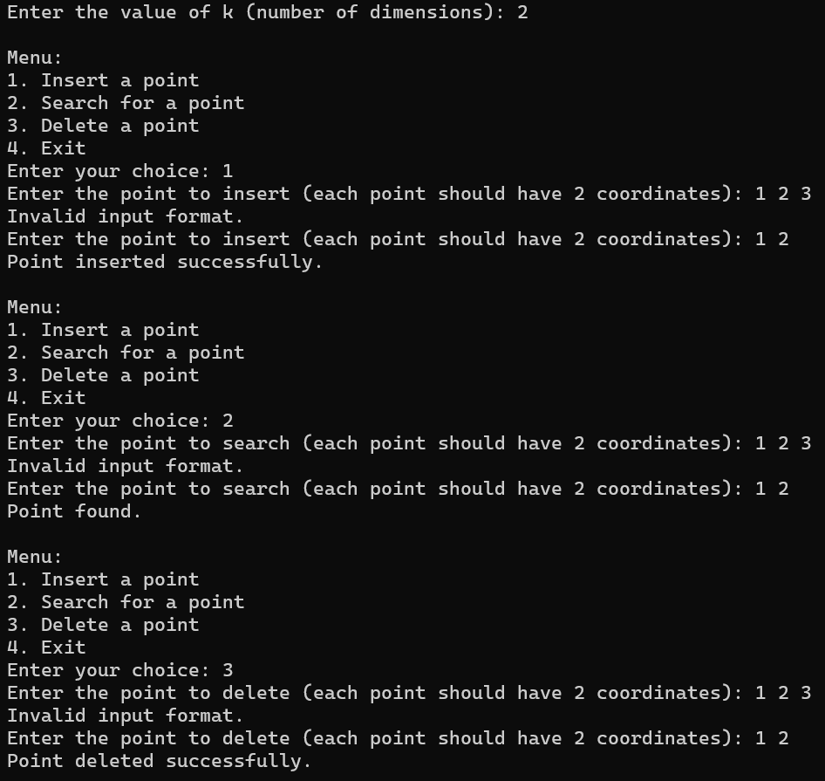

3-dimensional tree

